Self Practice with aaBridge (with dealer generated hands)
>>>>>>>>>>>> for Practice on BBO see the final page <<<<<<<<<<<<<<<<<<<

Compiled by Roger Pfister http://RogerPf.com/aaBridge roger@RogerPf.com
Within aaBridge is the 'aaBridge Document Collection', it can be accessed when using aaBridge via Menubar see the top menu entry under Help & How do I.
In there you will find the dealer scripts package with a name like dealer_scripts_v6.01.zip
That package describes how to run and if you want to even write dealer scripts that can be used to generate hands for both BBO and aaBridge.
Many users do not want to get into that level of complexity straight away (or even at all), so this document and a set of pre-generated hands have been produced.
This document covers how to best use the generated deals that are made by the dealer program when it processes a script.
For simplicity aaBridge comes with a set of built-in generated hands made by running the scripts is available in the above dealer scripts package.

You can find these generated script files in aaBridge from the menubar
BooksL > System - Self Practice
(Hint - Once there you can use the Toggle Chapter Mark button [top left] to easily return later.)

So you have gone to the above location or someone has sent you a generated file with a name like
nml__1N_15-17__Opps_intervene__LEB.pbn
(FYI - This is a set of hands that allows you to Self Practice Lebensohl over a normal standard (nml) 15-17 NT)

To get such a .pbn file into aaBridge you will need to Drag and Drop it on to an open aaBridge window. (Double click will NOT work for .pbn files, even for Windows users).

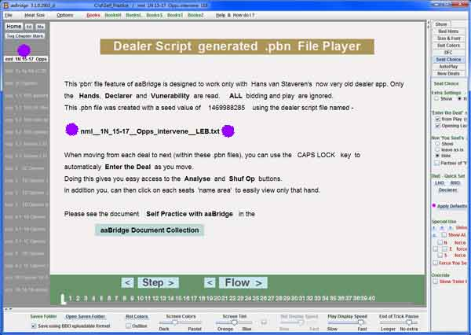
You will see a first page like the one shown here.

In this example you have a list of .pbn files showing in the left hand column. Single purple dot.

The file name of the script file that was used to generate the hands will show in the center of the screen. (Two purple dots.)

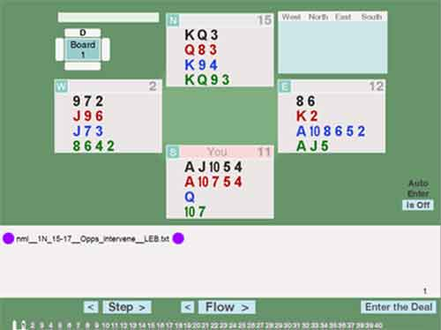
Click the Flow button or better still use your mouse wheel to move to move to the next page.
Here you can again see the file name of the script file that was used to generate the hands. (Two purple dots.)
At the very bottom of the image on the right is a line of numbers. These show 40 deals and we are currently viewing the first one.

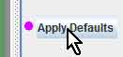
It is always a good idea to click the Apply Defaults button. It has a distinctive near by pink dot. That way you clear away any unwanted previous settings.

All you need to do is to click Flow (or use your mouse wheel) and you will see all the deals rapidly shown to you. Doing this has a number of disadvantages
- You can see all four hands
- It requires a lot of clicks to only show one hand and then moved to another.
- It requires many clicks, for EACH DEAL, to use the Analyse and Shuf Op buttons.
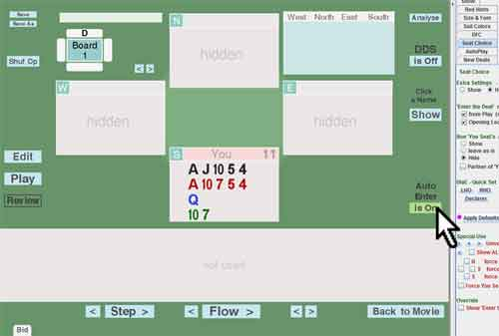
The best way around these issues is as follows

Auto Enter
On the right hand side, in the green area is the Auto Enter button.
Click the Auto Enter button to the feature on.
When you now click Flow or use your mouse wheel to go forwards and backwards then the first page that we saw above will now look as shown on the right. With only one hand visible.
If you click the Edit, Play or many other buttons you will come out of 'Auto Enter' mode.
FYI - The cards you see in the first hand of the current example LEB .pbn file WILL be different from those shown here as new hands are frequently generated for each build of aaBridge.
(For those that know aaBridge well - what being in 'Auto Enter ' mode does, is when you click Flow or rotate the mouse wheel, you are automatically moved out of the existing deal, as if you have pressed Back to Movie and then taken into the next deal as if you had then pressed Enter the Deal. )

Self Practice - Actually Doing It
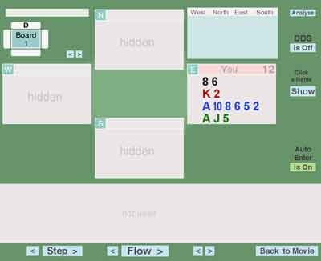
This example (LEB) is about as hard as it gets and it is still simple. You can see the South hand (the hot seat hand) you know that North will always be opening 1NT and so in your mind you tell yourself that partner has opened 1NT.

Next you need to click on East's name zone, where is now says 'You' in a pink box.

This will reveal the East hand and you can now decide East Intervention bid. In this case you have a choice between a natural 2 Diamond long single suit and a DONT style double showing a single suit of unspecified denomination.

Click on South's name zone and decide your best response (as defined by the bidding system you are trying to learn).

When you have decided your bid and "said it to yourself" then you can ...

Click on North's name zone and decide what North's response would be to your bid. (Here West will always pass.)

When the bidding is complete you can (if you wish to) reveal all the hands by the Show in the green area on the far right.
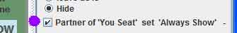
If you wish to see both the North and South hands as you bid then check the "Partner of ..." button (purple dot).

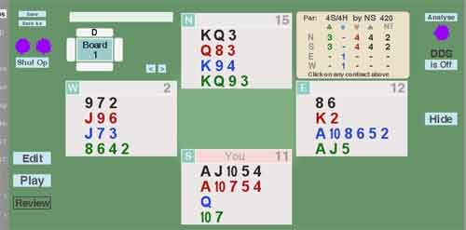
Analyse and Shuf Op
To get an idea off how often the contract you bid will make do the following.
Click Analyse (one dot) and look at the number of tricks (- 6) that your declarer will make.
Click Shuf Op (two dots) and the Opps hands will be shuffled and the Analyser will again show you how well you can expect to do on the new layout. After a few Shuf Op's you will start to get feel for how often it makes and how often it does not.
(Yes, I do know this is not particularly applicable in this case, as there is intervention bidding.)

<More on next page>

Practicing the Play of the Hand
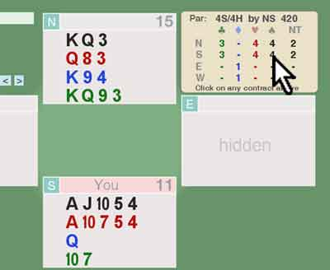
Should you want to play the hand and not just bid it then select from the Analyser box the contract you want to play in and click it.

Four Spades is in process of being selected on the right.

As you select the contract aaBridge will automatically
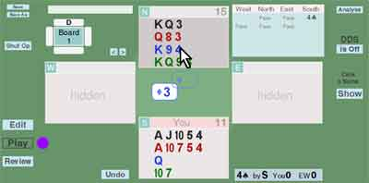

go into Play mode (purple dot) and West will play a card.

You will now need to play a card from dummy, here the 4 of Diamonds.

Not using Auto Enter mode - How to control the EW visibility

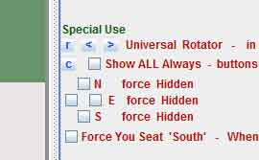
The Special Use settings can do this job.
Check the W and E settings (see image on the right, which shows them unchecked) and those hands will NEVER be shown.

The Universal Rotator is also useful in case you want to have the North and South hands reversed for the whole session.

Apply Defaults
Do remember to click Apply Defaults
button as the settings are remembered
between sessions.

<More on next page>

Practicing with Others on BBO
A good way to practice with others is to use the dealer scripts mentioned earlier.
Within aaBridge is the 'aaBridge Document Collection', it can be accessed when using aaBridge via Menubar see the top menu entry under Help & How do I.
In there you will find the dealer scripts package with a name like dealer_scripts_v5.0.zip
All you need to do is to copy and paste the script into the BBO advanced dealer. Full instructions given in the document in the zip file.

Starting from a .pbn file
Also in the 'aaBridge Document Collection' is a file called Self Practice example deals .zip
Once unzipped you will see a group of .pbn files like the ones under BooksL > System - Self Practice.
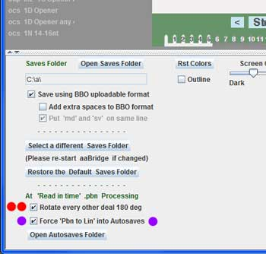
Which you might like to use as examples.
When you load a generated .pbn file can you make it load with every other deal rotated 180 deg. See the Red dots in the image on the right
Whenever you view a .pbn file aaBridge will automatically create a matching .lin file. If the .pbn file you are viewing is one of the ones that is built-in to aaBridge then the created lin file will be put in your Autosaves folder.
To view the Autosaves Folder click the
Open Autosaves Folder
button. (BELOW the two dots on the right)
If the .pbn file you are viewing is outside aaBridge then the new .lin file will be put in the same folder as that .pbn file.
You can force the lin file destination folder to always be the Autosaves folder by checking the check box shown with the two purple dots on the right
The created .lin file will have file name of the form
yyy__<name-of-the-original-dealer-script-file>__LIN.lin

Getting the new lin file up to BBO
Getting the new .lin file up to BBO so it can be used for deals on a teaching or bidding practice table is a standard thing to do. This is fully documented in the 'aaBridge Document Collection' file called
Get aaBridge hands up to BBO - a How to.doc

You can generate additional sets of hands with the dealer script_v5.3.zip in the doc collection

<end of document>

